**CP1406 - Assignment 2 - Project Plan Name:** Barrier Reef orchestra

**Mission Statement:**

The main focus of the redesign of the Barrier Reef Orchestra website is to attract younger attendees and musicians; to increase the attendance base and orchestra members.

To have the orchestra be seen as a must-see attraction to locals, visitors and tourists alike, providing the best talent from home, remote and abroad.

Another focus is to instil an air of prestige and community ownership that will extend from the online platform to provide exposure to potential members and donors.

The website will fulfil numerous different tasks, from providing online ticket sales, information of upcoming events, membership, donations, social media links and information on artists.

**Success Evaluation:**

The website must be easy to use and navigate whilst providing relevant information and a clean layout. Success of the website will be based on feedback, membership signups, analytics, social media presence, donors and orchestra applications.

Aiming for an increase of attendance of 25% over 12 months within the targeted age group of 15-30 years of age.

**Target Audience:**

The website is primarily targeting a younger audience base within the ages of 15 to 30. This target will mostly be comprised of late high school students and recent school leavers. Tourist and musicians are also prime targets for this age group.

To target this audience; the website will provide a fresh, easy to navigate user interface with easily accessible content, social media plugins to increase exposure and the flexibility and capability of working on a multitude of different devices and screen sizes.

**Content:**

* **All pages**
  + Sign up button
  + Sponsors
  + Sample music (Not auto play)
  + Contact information
  + Social media link
* **Home Page**
  + Call to action
  + Basic Introductory content
  + Meta info for search
  + Bulletin board
* About Us
  + Detailed information
    - Origins and History
    - Types of performances
* Events
  + Current and upcoming performances
  + Past performances/timeline
* Membership Registration
  + Info on membership benefits
  + (Application to join orchestra?)
  + Membership signup
* Artist
  + Orchestra Members
  + Solo artists
  + Conductors
* Feeder/Examples/Music
  + Examples of music

**Flowchart:**

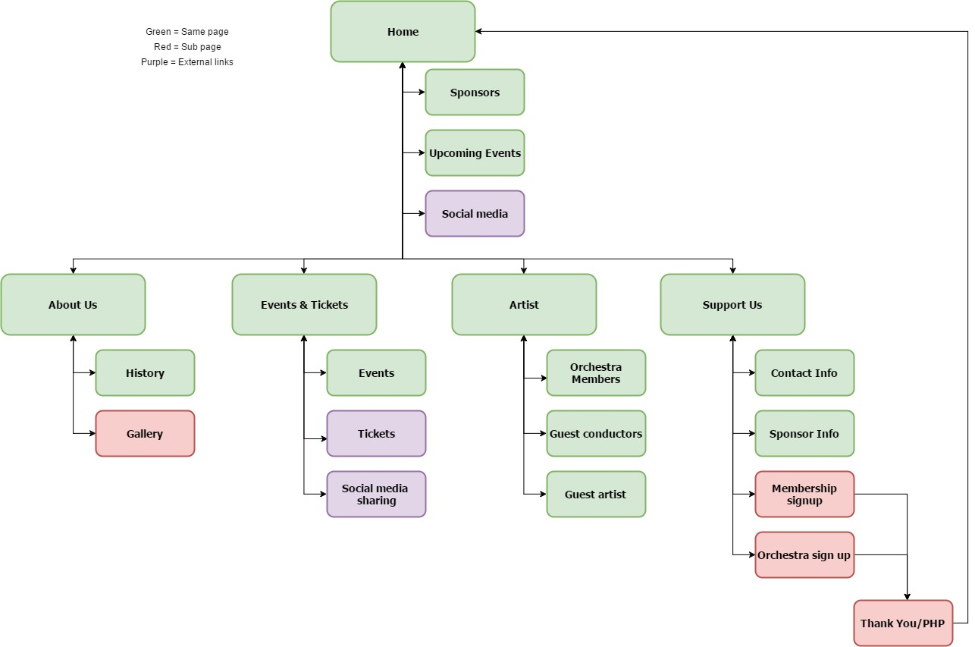

**GitHub link**

<https://github.com/JoshuaGuernier/OrchestraWebSite>